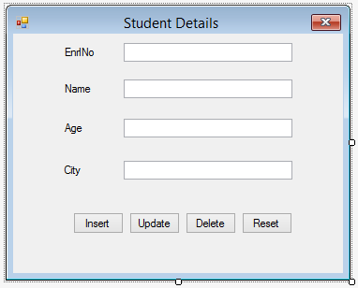
btnReset
btnDelete
btnUpdate
btnInsert
txtCity
txtAge
txtName
txtEnrlNo

Database Table Structure
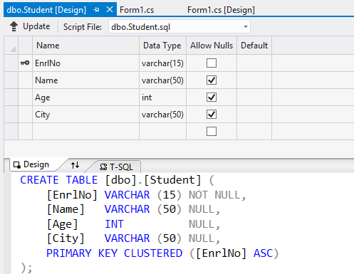

Reference Code:


